Plate Boundaries: class worksheet; use as a study guide for exam #1

Reading a tectonic map
Use the map below to answer the questions.
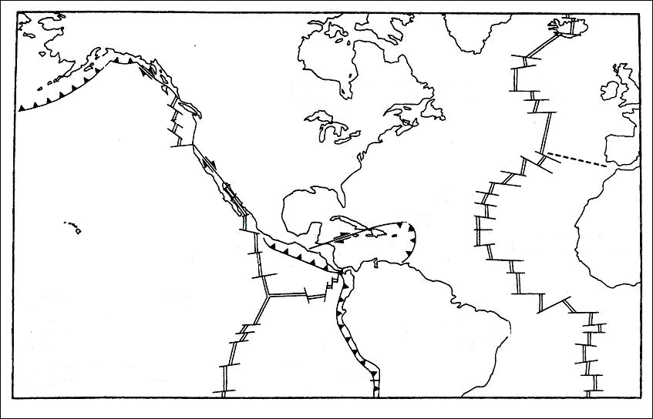

- Sketch the symbol that represents a divergent plate boundary.

- Describe the process that occurs at a divergent plate boundary.

- Name several features characteristic of this plate boundary.

- Sketch a cross-section of this boundary and label with the terms listed in question #3.

- Sketch the symbol that represents a convergent plate boundary.

- Describe the process that occurs at a convergent plate boundary that contains oceanic crust.

- Name several features characteristic of a convergent plate boundary that contains oceanic crust.

- Sketch a cross-section of a convergent plate boundary that contains oceanic crust and label with the terms listed in question #7.

- Sketch the symbol that represents a transform plate boundary.

- Describe the process that occurs at a transform plate boundary.

