Overview
The continuous increase of system power and the decrease of available volume present interesting challenges in the thermal management of electronics. Traditional design has relied on natural convection from a heat sink placed directly on the device. With the increasing power of today’s devices, it has been necessary to add a fan to these local heat sinks. But fan sinks placed directly over the device occupy a lot of space. Heat pipes provide the system designer with a powerful tool. The heat pipes transport heat away from the obstructions and constraints of neighboring boards to where it can be conveniently dissipated. A heat pipe heat sink is a passive cooling device that requires no moving parts and operates silently and reliably. Heat pipes have emerged as an effective and established thermal solution, particularly in high heat flux applications and in situations where there is any combination of non-uniform heat loading, limited airflow over the heat generating components, and space or weight constraints.
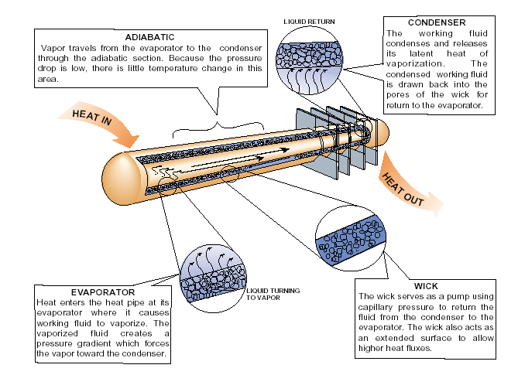
Figure: Heat Pipe operation (Courtesy Thermacore Inc.- http://www.thermacore.com)

A heat pipe is a passive heat transfer device with an extremely high effective thermal conductivity. Its two-phase heat transfer mechanism results in heat transfer capabilities from one hundred to several thousand times that of an equivalent piece of copper. Heat pipes are sealed vacuum vessels that are partially filled with a working fluid, typically water in electronic cooling, which serves as the heat transfer media. The heat pipe envelope is made of copper in a numerous shapes including cylindrical, rectangular, or any other enclosed geometry. The wall of the envelope is lined with a wick structure, which provides surface area for the evaporation/condensation cycle and capillary capability. Since the heat pipe is evacuated and then charged with the working fluid prior to being sealed, the internal pressure is set by the vapor pressure of the working fluid. As heat is applied to the surface of the heat pipe, the working fluid is vaporized. The vapor at
the evaporator section is at a slightly higher temperature and pressure than other areas. This creates a pressure gradient that forces the vapor to flow to the cooler regions of the heat pipe. As the vapor condenses on the heat pipe walls, the latent heat of vaporization is transferred to the condenser. The capillary wick then transports the condensate back to the evaporator section. This closed loop process continues as long as heat is applied.

This experiment shows effectiveness of heat pipe for heat conduction compared to a metallic rod (Copper in our experiment) by comparing its heat removal rate.

Method
The heat pipe and copper rod should be in the test section in a vertical position, similar to what is shown in the figure. Three K- type thermocouples are placed at different locations on the periphery for both heat pipe and copper rod. These will be used to measure the rod surface temperatures. Place a beaker with water under test section such that 80% of evaporator section of the heat pipe as well as the bottom of the copper rod is in the water. Place the water beaker on a plate heater as shown in the figure. Place two separate thermocouples: one to measure air temperature inside the test section and other to measure the water temperature. Also during this time, zero the manometer used with the orifice plate. Do this by turning the knob on the right side of the manometer and moving the scale until the “0” point lines up with the bottom of the red fluid. Orifice plates are used mainly incorporated for measuring air flow rate, velocity or Reynold’s number. In our experiment we are measuring velocity as well as Reynold’s number by EES software which uses empirical correlations for orifice plate to calculate the above mentioned properties.

Turn on the plate heater to its full capacity. Wait until the water temperature reaches up to 85°C. Once the thermocouple reaches the desired temperature, turn on the wind tunnel. Put the variac at a reading of 100%. This means that the fan will be operating at 100% of its rated speed. You can start taking measurements as soon as steady state condition is reached. You can make it sure by observing thermocouple readings. When the readings are stabilized then the steady state condition is reached. Measure six different temperatures from thermocouple: three for heat pipe (T_{h1,} T_{h2,} T_{h3)} and three for copper rod (T_{c1,} T_{c2,} T_{c3)}. Also record the air temperature using the thermocouple that has been placed in the inlet to the wind tunnel. Measure the pressure drop across the orifice plate using the manometer. Estimate how accurately you can read the manometer. From this pressure drop, you will be able to determine the air velocity. Repeat the procedure for four different water temperatures 70ºC, 75ºC, 80ºC and 85ºC respectively.

Calculations

- Use EES software to calculate Reynolds Number (Re) and Velocity (V) in the test section. The program can be downloaded from your instructor’s website using the password provided in class. Calculate these properties at film temperature (T_{f}).

Where T_{f} = (T _{air} + T _{surface}) /2
T _{surface} = (T_{S1}+T_{S2}+T_{S3}) /3

- Use an empirical correlation to find the average Nusselt number and then heat transfer coefficient over the heat pipe and the copper pipe, which both can be treated as cylinders. The heat pipe diameter is 0.06m, and the copper rod diameter is 0.059m.

- Find out total heat removed in Watts (Q) for both the heat pipe and rod for each temperature. The exposed surface area of the heat pipe is πD_{p}L_{p} and of the copper rod is πD_{c}L_{c}.

Items to turn in:

- A short memo (2 pages maximum) following the typical memo format (remember to include goals/objective, experimental methods, results, and a discussion of results). In the results section, plot heat transfer Q as a function of water temperature for both the heat pipe and copper rod.

- An appendix giving all calculations, including the equations used to calculate Nu and h.

