Development of Chassis Impedance and Fan Curves
ME 146 Lab 1

Introduction
As the size of electronic enclosures decreases it is important to understand the effects that this can impose on thermal management. A poorly designed enclosure may increase the restriction of airflow to areas where cooling is most needed. As well as optimizing airflow through the enclosure, fan selection and placement can improve cooling effectiveness. This lab involves the development of chassis impedance and fan curves, which are important if one is to know the airflow through a system. In Lab 2 you will use these fan curves as you look at the thermal performance of a computer chassis under various conditions.

System Airflow Impedance
As the word implies, impedance is an obstruction to movement, in this case an obstruction to the flow of air. As the flow slows down due to ‘impedances’, a pressure gradient is formed upstream of the obstacle. This static pressure drop represents the impedance of the system and works in opposition to the flow. The summation of individual impedances contributes to the system’s overall static pressure drop, which is represented by an impedance curve (Figure 1).
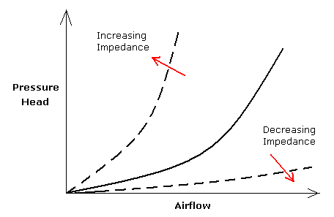
Figure 1. Impedance Curves. Increasing or decreasing the impedance dictates how much air can flow within a system.

The impedance curve represents the amount of static pressure head a flow must overcome to achieve the desired flow rate. An impedance curve is generated empirically by measuring the static pressure drop within the system using a wind tunnel. For this lab, we will induce airflow impedance by adjusting the size of our airflow inlet. Besides adjusting the inlet and outlet areas, what other factors would cause an increase in static pressure in a computer chassis?

Series vs. Parallel Fan Configurations
To compensate for the impedance of the system, either one fan or a combination of fans--in series or parallel--are used. Figure 2 illustrates a series fan configuration and its relation to the impedance of a system. The effect of this configuration doubles the amount of system impedance the fans can overcome for a given flow rate. For high impedance systems, a series fan configuration would be optimal since this configuration is able to deliver higher airflow rates.

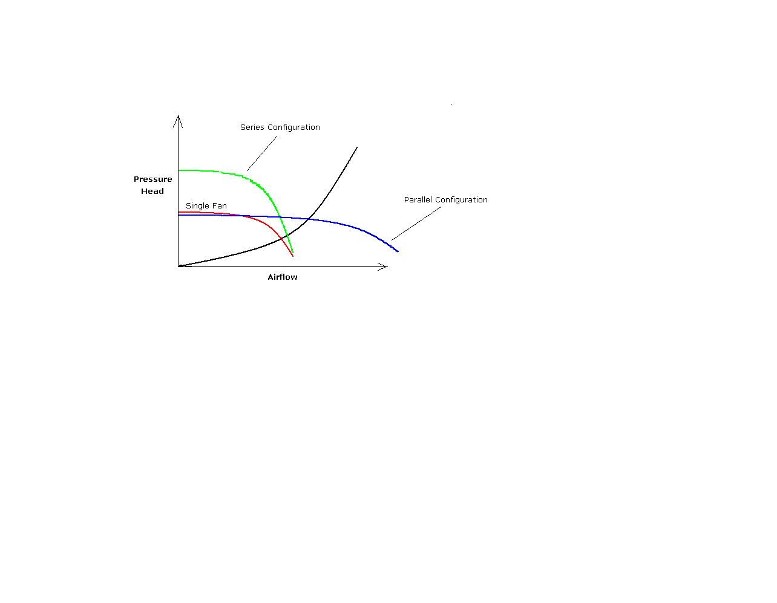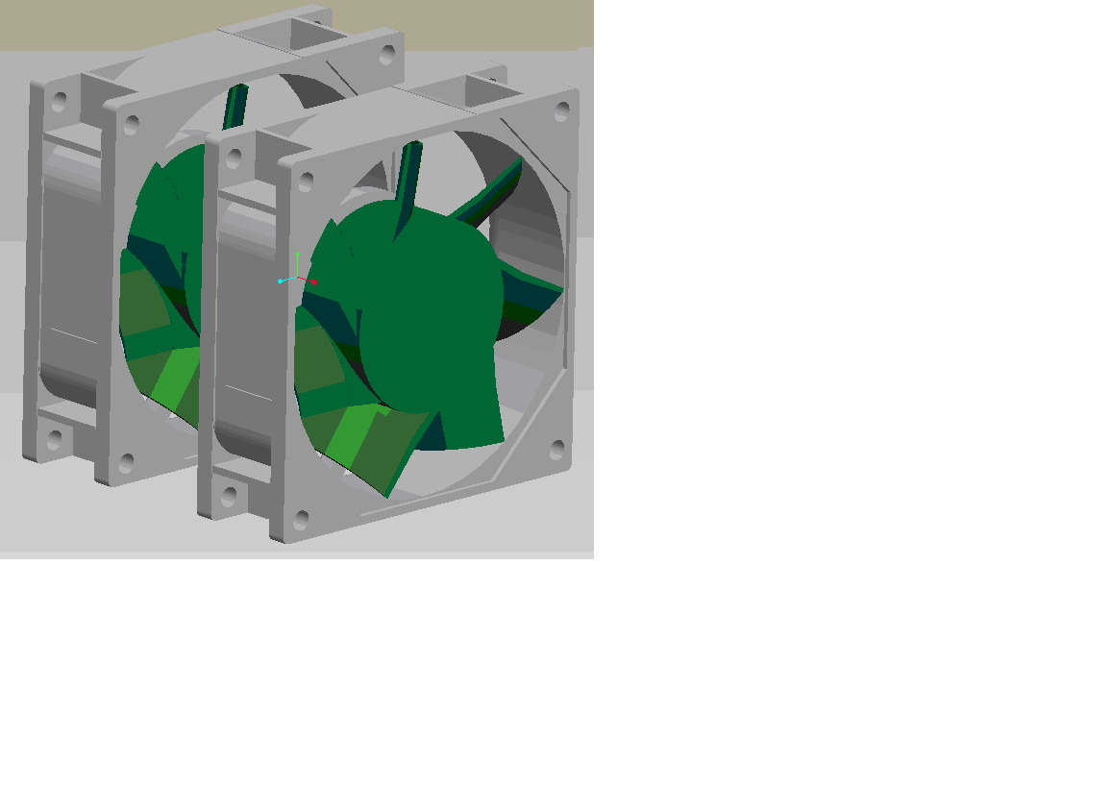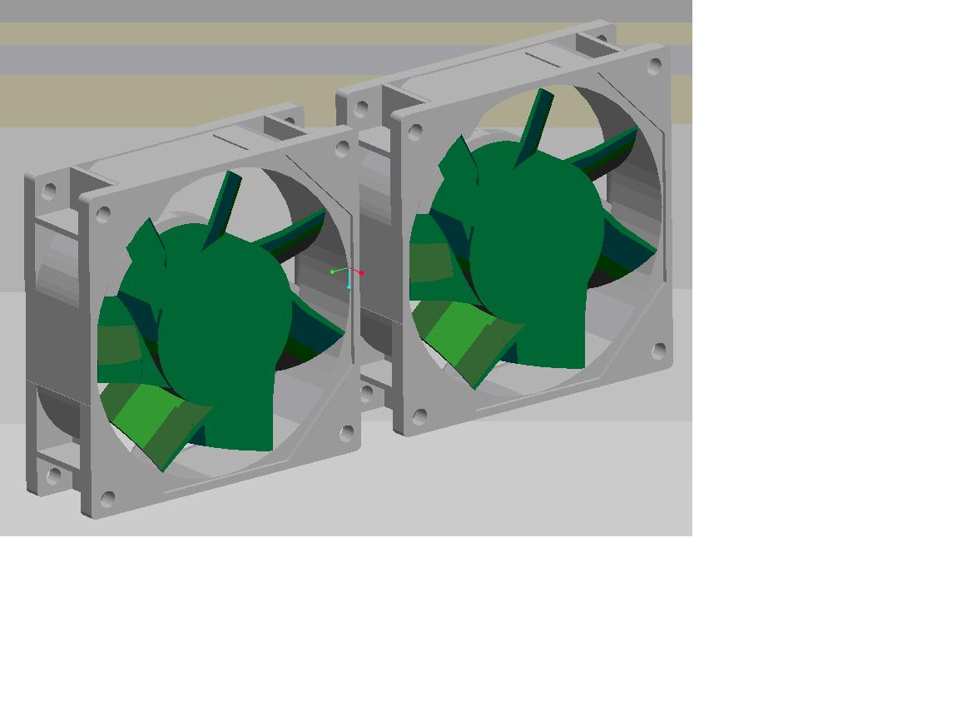
Figure 2. Comparison of Series and Parallel Fan Configurations in Relation to the System Impedance Curve.

Also depicted in Figure 2 are the parallel configuration and its relation to the impedance of a system. Adding a second fan in this configuration doubles the rate of flow for a given pressure drop. For low impedance systems, there may be no need to overcome a larger pressure drop, making the parallel fan configuration ideal for increasing air flow.

As you know, the higher the air flow rate, the higher the heat transfer coefficient and hence better heat transfer. It is important to be able to estimate the air flow rate in your system. The operation point of the fan and chassis is indicated by the intersection of the fan curve and the system impedance curve, as shown in Figure 3. With this information, decisions can be made regarding the size of the fan and the pressure drop of the system.
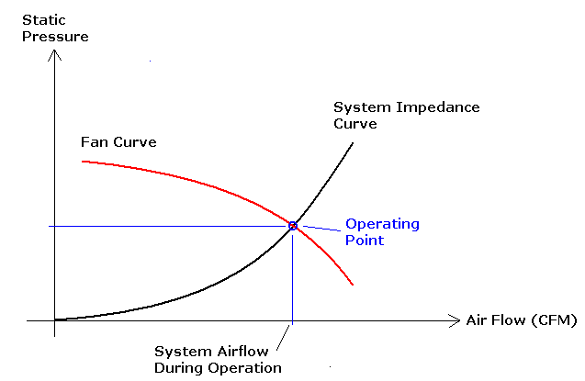
Figure 3 Typical fan and system impedance curves
Goals:
The purpose of this lab is to gain an understanding of fan and system impedance performance, including the effect of having two fans in parallel or in series. A secondary purpose of this lab is to gain experience using common experimental equipment, including a specialized wind tunnel, venturi meters, and manometers.

Apparatus
The main piece of equipment to be used in these tests is an AMCA 210-99 Airflow Test Chamber from Airflow Measurement Systems, shown in Figure 4. The wind tunnel is comprised of two sections: the front chamber where the static pressure is measured, and the rear chamber where the downstream pressure is measured (See Figure 5). Separating these two sections is a barrier with an assortment of venturi nozzles. Opening one of
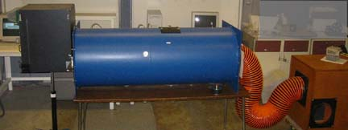

Figure 4 Airflow Test Chamber

these nozzles allows air to flow and creates a flow pressure difference between the two sections.
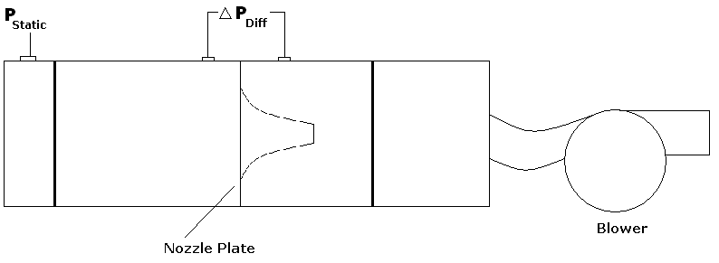
Figure 5 Schematic of Airflow Test Chamber. Here (and in Figure 2) the system being tested is attached on the left hand side, and air flows from left to right.

Venturi meters are designed following strict standards set by ASME to measure flowrates. The general idea behind them is that the faster the air flows, the greater the pressure drop through the venturi. Thus, if the pressure drop across the venturi is measured, the CFM through it can be determined either by using standard ASME equations or graphs. In this case, we will be using graphs provided by the wind tunnel manufacturer.

We also need to know the pressure drop through the system. The pressure entering the computer chassis will be atmospheric. Since the chassis is attached on the left hand side in Figure 3, the pressure drop through the system can be determined by subtracting the static pressure measured from the atmospheric pressure.

The static and differential pressures are measured using manometers mounted next to the wind tunnel (See Figure 6).

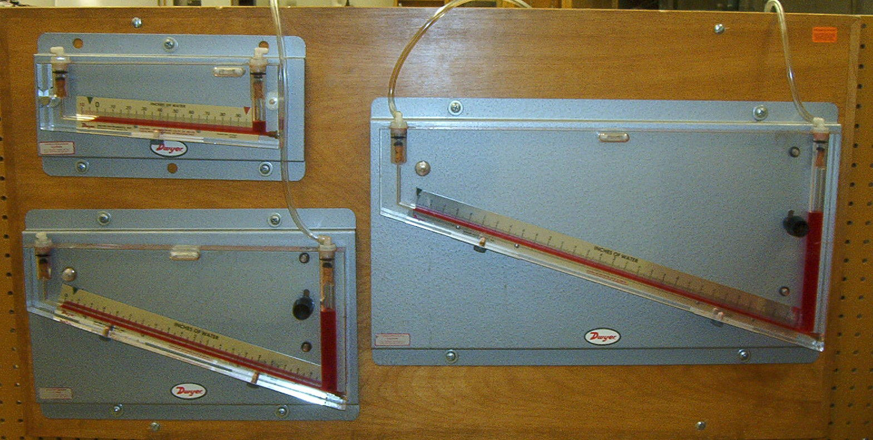
Figure 6 Manometers used to measure pressure drop. For the best accuracy, use the smallest manometer that works for your pressure drop.

Procedures

Here you will be developing two system impedance curves and three fan curves. Start with the system impedance curves. The computer chassis should already be connected to the wind tunnel. Here are some steps to follow:

Impedance Curves

- Set up your computer chassis with either a series or a parallel fan configuration. Place the exit of the chassis in either the closed position or open position, as instructed by your professor.
- Choose the appropriate nozzle to measure the CFM. Note that the smaller the venturi nozzle, the larger the pressure drop through it. The larger the pressure drop, the more accurate it will be. However, if it’s too large, it may be greater than the maximum that your manometers can measure. You may need to try several different venturis to find the best one for your application. To choose a venture, check out the pressure drop-CFM curves in the instruction manual for the wind tunnel.
- To install the appropriate venturi, open the black door in the top of the wind tunnel. Find the venturi size that you chose. Turn the handle of the venturi until it is loose, and remove it. It will still be tight. If there is another venture that was out previously, you will need to put that one back in. Make sure the handle is loose, and push it back in to the appropriate hole. Then tighten the handle.
- Start up the blower. To do so, hit “Display” until “Lo/Re” is lit. Then use the arrows to select “Low.” Then go back to “FREF” and push run. Crank up the speed using the knob. Record the resulting chassis and venturi differentials over a range of flow rates. For all cases except parallel fans with chassis exit open, go from 0-35 CFM. For parallel fans with chassis exit open, go from 0-45 CFM. You must decide as a team how many data points are needed to develop a good curve! You should have at least ten. You must also decide which manometer is best to use and how to set up the manometers to measure pressure drop across the venturi and across the chassis. Have your instructor check your setup before you start recording data. Also, make sure to record the zero point of the manometers if you can’t zero them before you start taking data.
- Repeat the process once; then when finished hit “Stop” on the blower controls.
- Interpret the differential pressures to obtain CFM

Before you leave the lab, sign up for a lab station to use for the next lab. Measure the geometry of the heat sink for that lab station as best you can. You will not be able to remove the heat sink.

Fan Curves

Fan curves are generated by attaching the fans directly to the wind tunnel; they are removed from the chassis.

1) Insert either the parallel, series, or individual fans through the BACK of the foam board (opposite the direction that it seems like they should be). The fan power cords will need to be placed between the foam board and the fans. Tape the foam board to the open end of the wind tunnel.
2) Place computer chassis number 3 on the table near the exit of the wind tunnel. Attach the fan power cords to the fan power of the computer chassis. The computer chassis will need to be close to the fans since the cords are short, but try to place it somewhat to the side to minimize interference.
3) We will first measure the system pressure drop when there is no flow. To do so, install ALL of the venturis so there is no where for the air to go. Turn on the computer chassis, starting the fans. Measure the static pressure using the manometer. The other end of the manometer should be open to the atmosphere. This will give you the pressure gain provided by the fan. Make sure to either zero the manometer before use or else subtract the zero point from all readings.
4) Now take out the 1” nozzle.
5) Turn on the wind tunnel fan. To do so, hit “Display” until “Lo/Re” is lit. Then use the arrows to select “Low.” Then go back to “FREF” and push run. Crank up the speed to a low frequency. About 15 Hz is a good start for parallel fans and 10 Hz for series.
6) Close the gate (the white plastic piece with a handle by the end of the wind tunnel opposite your fans being tested). Now slowly open it until a differential pressure across the venturi of about 0.1” H₂O is reached. Record the static and differential pressure.
7) Take more data points by slowly opening the gate. As you open the gate, the venturi differential pressure should be going up and the static pressure going down. Once the gate is all the way open, you can increase the flow rate by increasing the wind tunnel fan frequency. Do not go above a speed that give a venture differential pressure of 4” H₂O. You should have at least ten data points over the entire range.
8) Repeat the process once; then when finished hit “Stop” on the blower controls.
9) Now use the graphs to determine the CFM for each data point.

Before you leave the lab, sign up for a lab station to use for the next lab. Measure the geometry of the heat sink for that lab station as best you can. You will not be able to remove the heat sink.

Results and Discussion
1) You will need to email your pressure drop vs. CFM plots to your instructor within one calendar day of your lab. Put your results in Excel. She will combine all of the data and make it available on the web so each team can use all of the results in their report.
2) Put together three plots: impedance/fan curves for parallel fans, impedance/fan curves for series fans, and all three fan curves.
3) Estimate the CFM for our computer chasses for the parallel and series fan configurations.
4) Do the plots look like you expect from theory? Explain any discrepancies. What could be done to improve the accuracy of the results?
5) For the fan curves, why does the venturi differential pressure go up as the static pressure goes down? For the impedance curves, why does the opposite occur? Explain in your own words.
6) For a computer chassis, which would tend to be better – series or parallel fans? Why? What are the positive and negative aspects to using two fans instead of one big one?

