Lab 101: My First Digital Design

Objective: Introductory project walking through new project creation with PSoC Creator. Project uses PSoC Creator and the PSoC3 First Touch Kit (CY8CKIT-003) to blink a LED by writing to an I/O pin.

Activities and Procedures:

Start PSoC Creator

Create a new project

Select a project name: Lab 101 – My First Digital Design

Use the default workspace

Use the default device

Place a Digital Output Pin in your design
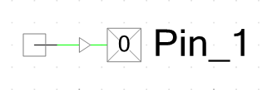

Double click on the icon to configure the digital pin as follows:
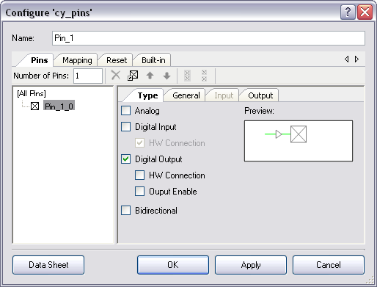

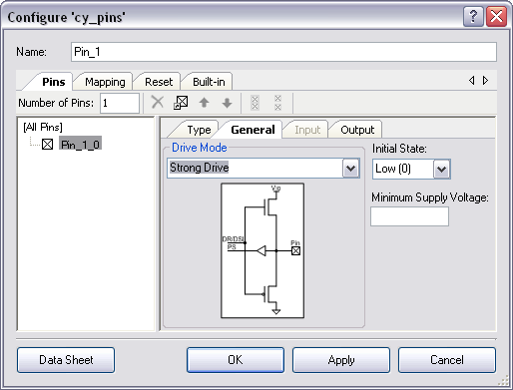

Close the configuration dialog.

Open the Design Wide Resource Manager (two methods)
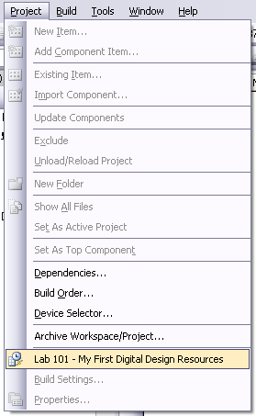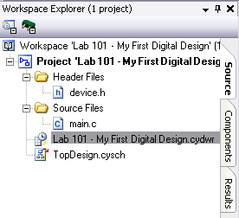

The Design Wide Resource Manager has several editors. Each editor has a Tab at the bottom of the manager. Select the Pins Tab.
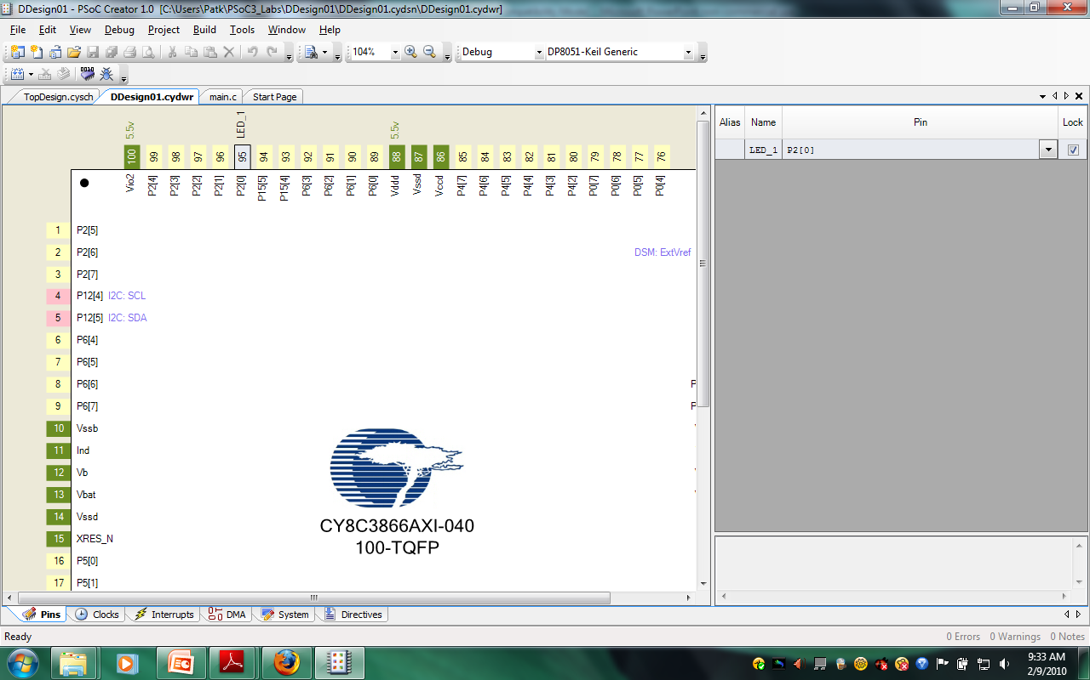

Assign Pin_1 pin to P2[0]. Drag from the row to the pin location or use the pull down from the Pin column.

Replace all the code in “main.c” with the code inserted from the “main.txt” file located in the “101 – Introduction to the Architecture and Design Flow/Lab/” directory.
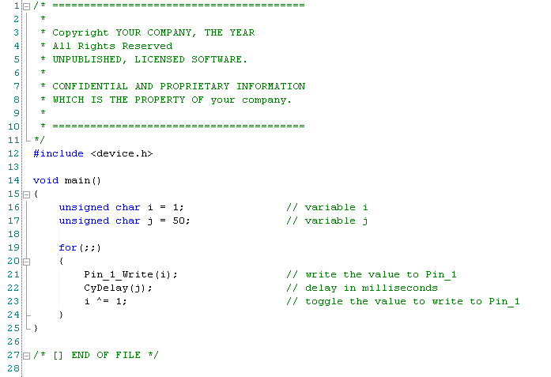

Build the project
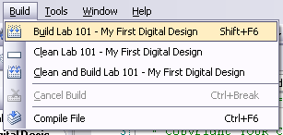

Start the debugger
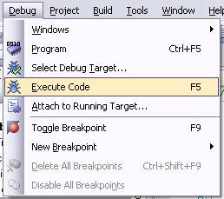

- Execute the code by Pressing Continue

