Exercise 6 - Error Clusters & Handling

Front Panel
- Open a new VI and build the following front panel using the following tips.

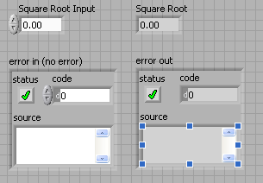

  - Create a numeric control and change the Label to Square Root Input. Create a numeric indicator for Square Root.
  - Place Error In 3D.ctl from Controls»All Controls»Arrays & Clusters.
  - Place Error Out 3D.ctl from Controls» All Controls»Arrays & Clusters.

Block Diagram

- Build the following block diagram.
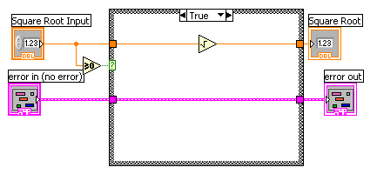

  - Place a Case Structure from Functions»Execution Control palette.
  - Place a Greater or Equal to 0? from the Functions»Arithmetic and Comparison»Comparison palette and wire it to the condition terminal of the case structure.

In the True Case:
  - Place the Square Root function from Functions»Arithmetic and Comparison»Numeric palette.

In the False Case:
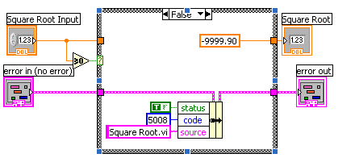
  - Create a numeric constant from Functions»Arithmetic and Comparison»Numeric palette and type -9999.90.
  - Place the Bundle By Name from Functions»All Functions»Arrays & Clusters palette. Wire from Error in to the center terminal of Bundle by Name to make status show up. Create constants. Wire from the Error Out indicator to the output of Bundle By name.

3. Save the VI as Square Root.vi.
4. Display the front panel and run the VI.
5. Save and close the VI.

End of Exercise

